**HANOI-APTECH INTERNATIONAL PROGRAM TRAINING SCHOOL**

**PROJECT REPORT**

**GIFTS SHOP**

Project report made by 2 students:

1. DUONG LE DOAN
2. ANH NGUYEN LE TUAN

Table of Contents

1. Introduction 1

2. Statement of the Problem 2

3. User Requirements 2

4. Objectives 3

5. Scope of the Project 4

6. Screen shot & description 5

7. User Guide 7

# Introduction

This is a brief introduction to our project - the "Gifts Shop" gift e-commerce website. This project is implemented using HTML, CSS, and JavaScript.

"Gifts Shop" is an e-commerce website aimed at providing a convenient platform for users to purchase special gifts for occasions such as birthdays, anniversaries, or other important celebrations. The website is designed with a user-friendly interface that is easy to navigate.

We have used HTML to build the structure and content of the website, CSS to create an attractive and smooth interface, and JavaScript to implement interactive features such as viewing product details, displaying products by category, and filtering products by brand.

We hope that the "Gifts Shop" website will provide users with an enjoyable and convenient shopping experience. We have put efforts into creating a user-friendly interface and an efficient product management system.

Thank you for taking the time to review our project.

# Statement of the Problem

GIFTS ONLINE is selling various types of Gift Items. The company advertises by

distributing the pamphlets, advertising on television and so on. Due to rapid

development in internet field, the company decides to launch a website where people

will get all the information about the various products available with them easily.

You are supposed to create a website for them with the below mentioned

requirement specifications.

The website is to be developed for the Windows Platform using HTML5, JavaScript

and Geolocation. The site should work well in all leading browsers including Chrome,

IE, Firefox etc.

# User Requirements

The Web site is to be created based on the following requirements.

1) The Home Page should be created making use of Frames with a suitable logo.

2) Home Page should contain details of Gift Items with suitable images.

3) The site should display a menu which will contain the options for brief

introduction about the various gift items available, location of the shop and

any other information if required.

4) The information about products should be presented in two ways:

(a) Information should be available category wise, wherein user can

click on a particular category and should be able to view all the

products related to the category available with complete

information. Eg. Category can be “Mugs”, “Cards”, Bracelets” etc.

with suitable sub-categories been defined.

(b) Information should be categorized according to the brand names of

the products like if a User wants to see only “Hallmark” products or

any other company’s products then he/she can click on a

Link/button/menu etc and can see only that Brand products.

5) When a user selects any particular brand, a list of products for that brand will

be displayed

6) A brief summary of features of individual products should be displayed on the

Web Page along with the product but detailed Features should be stored in

Individual Word documents which can be downloaded or viewed by the User

who wishes to see the same.

7) The user should also be able to compare the various products of different as

well as similar brands.

8) There should be a “Contact Us” page which will have the Address of the

Company which is as follows and the mail address which when clicked will

invoke the local mail client from where they can send an email. Address of the

Company should be displayed using GeoLocation API (eg. GoogleMaps).

# Objectives

The goal of the project is to develop a web application for an organization selling gifts. The main objectives of this website development can be defined as follows:

• To develop a system that provides functions to support the organization in conveniently displaying their product information.

• To provide product categories based on the type of gift or occasion.

• To provide a search function for customers to easily find a specific gift.

• To provide a function for customers to directly contact the organization via email.

By achieving these objectives, the "Gifts Shop" website aims to create a user-friendly platform where customers can explore a wide range of gift options, easily navigate through different categories, find the perfect gift for any occasion, and conveniently contact the organization for any inquiries or requests.

Through this project, we strive to deliver an enjoyable and seamless shopping experience for users, ensuring that they can find the ideal gifts and have a smooth interaction with the organization. Thank you for considering our project.

# Scope of the Project

Scope of the "Gifts Shop" project refers to the boundaries and extent of the project's objectives, deliverables, and activities. It defines what is included and excluded from the project. In the context of the "Gifts Shop" project, the scope can be outlined as follows:

1. Website Development: The scope includes the development of a fully functional website for the "Gifts Shop" organization, focusing on the selling of various gifts.

2. Product Information Display: The scope encompasses the implementation of features to showcase product information, including details, images, prices, and availability.

3. Product Categories: The scope involves creating different categories for gifts based on types or occasions to facilitate easy navigation and search for customers.

4. Search Functionality: The scope includes incorporating a search feature that allows customers to search for specific gifts using keywords or filters.

5. Contact Functionality: The scope covers implementing a contact function that enables customers to directly communicate with the organization via email.

6. User Interface (UI) and User Experience (UX): The scope encompasses designing an intuitive and visually appealing user interface, ensuring a smooth and engaging user experience throughout the website.

7. Integration of HTML, CSS, and JavaScript: The scope involves utilizing HTML, CSS, and JavaScript to build the front-end components and functionality of the website.

It is important to note that the scope may vary depending on the specific requirements and agreements between the project team and stakeholders. It should be clearly defined to ensure a focused and successful execution of the "Gifts Shop" project.

# Screen shot & description

- Header



- Footer

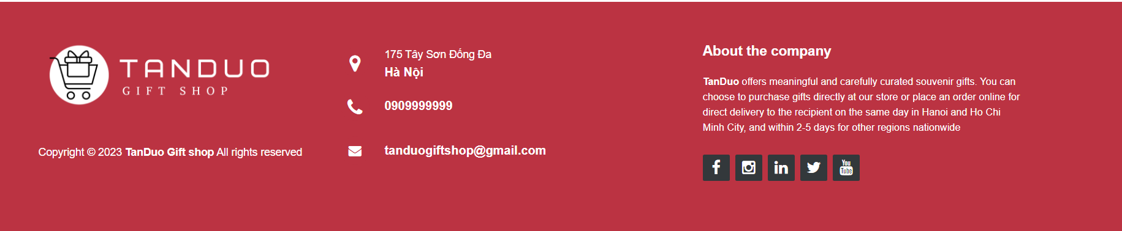

- Homepage

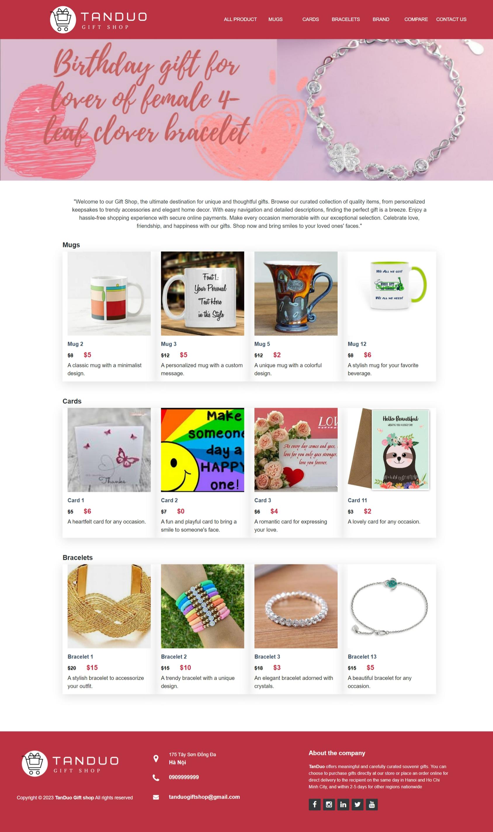

- All Products

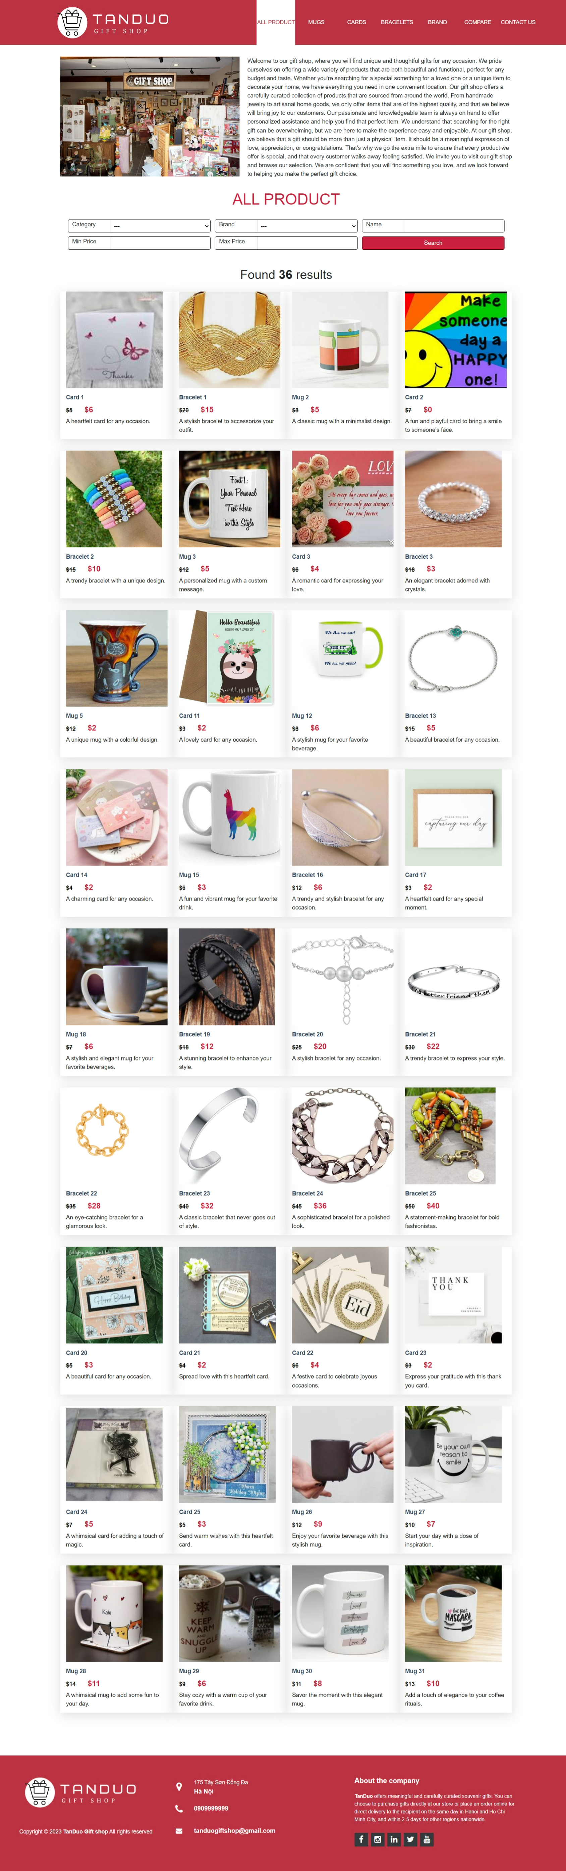

- Products by category

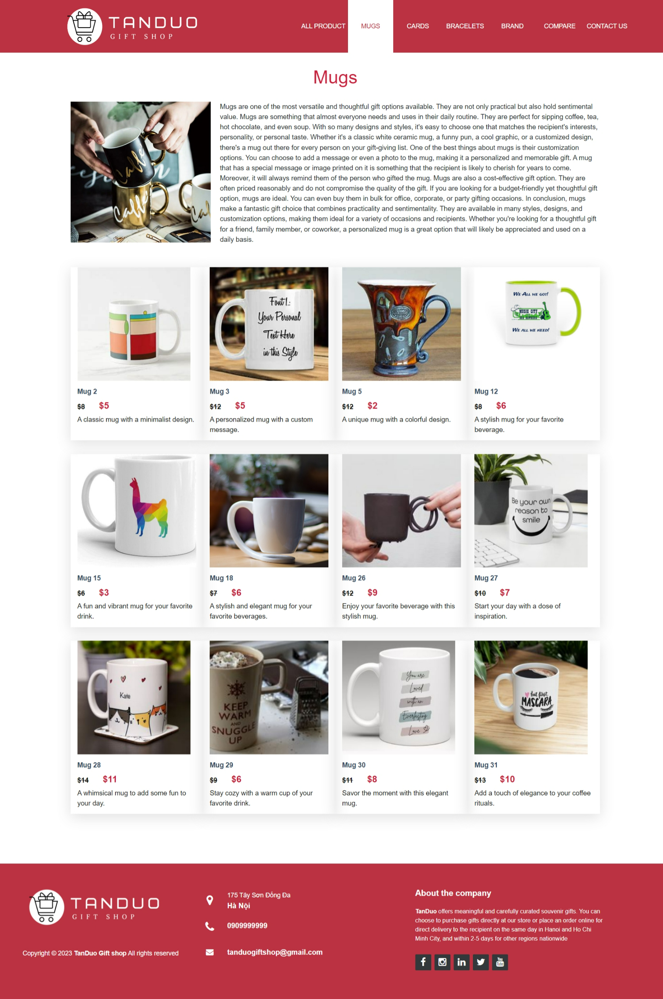

- Products by brand

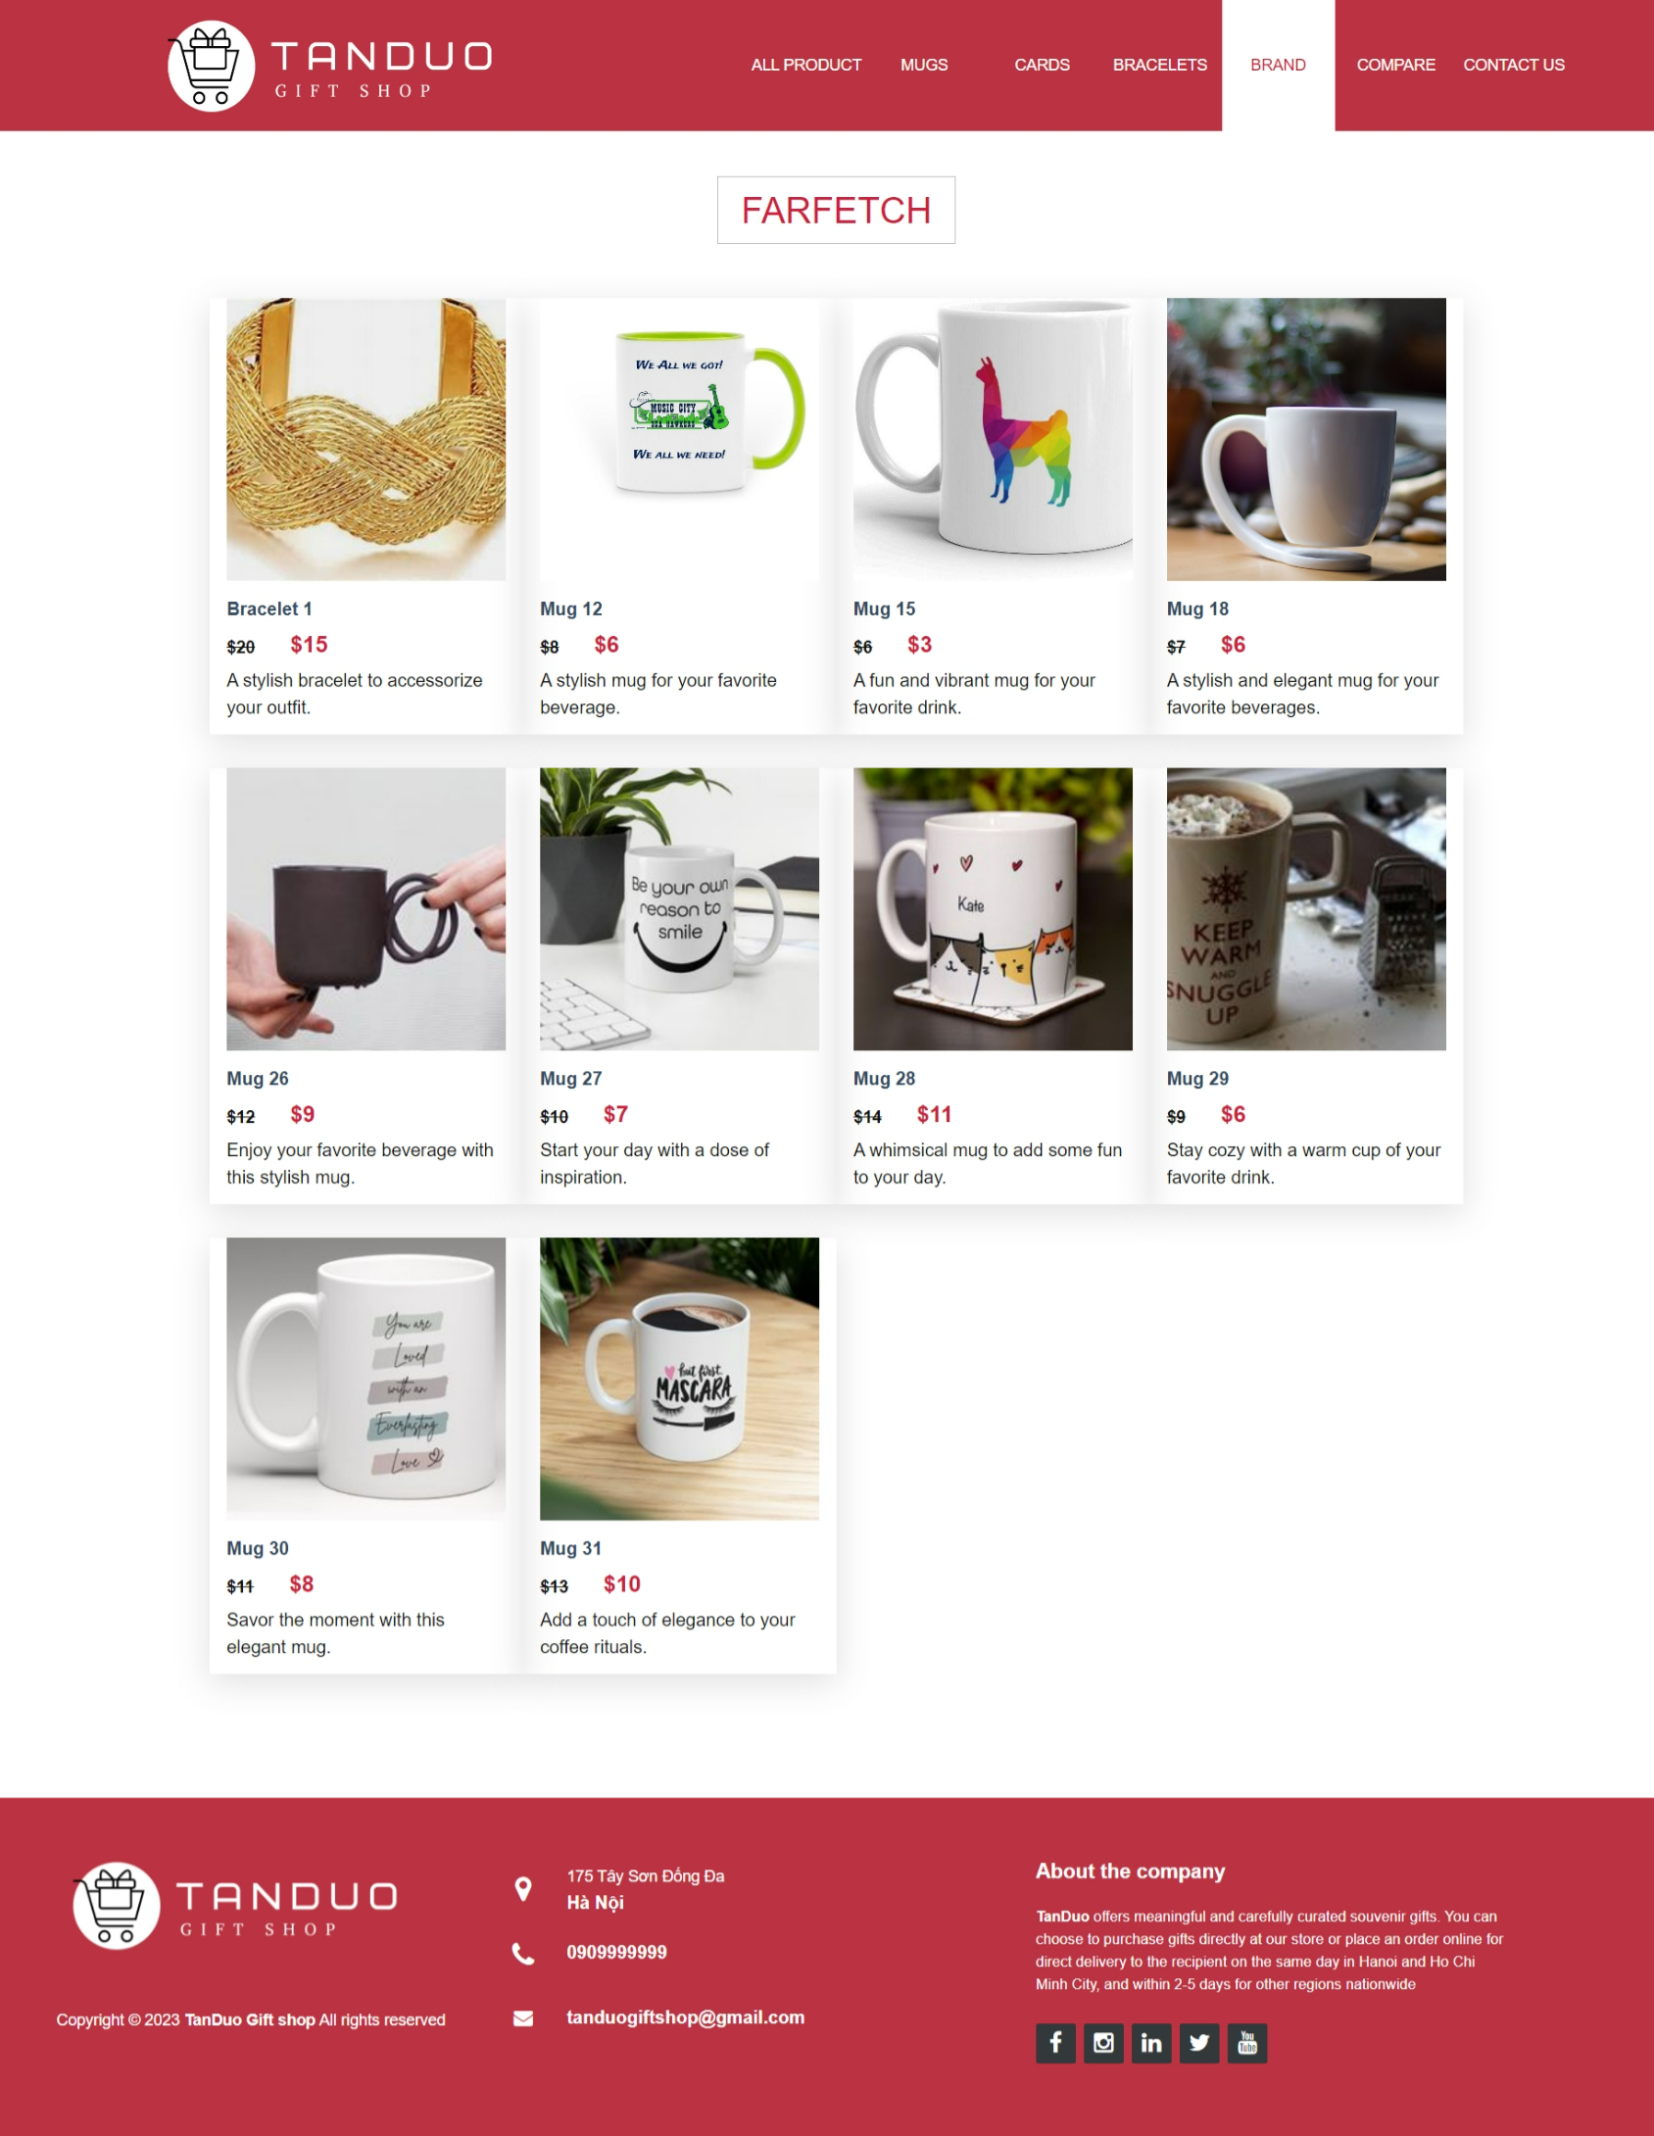

- Product comparison page

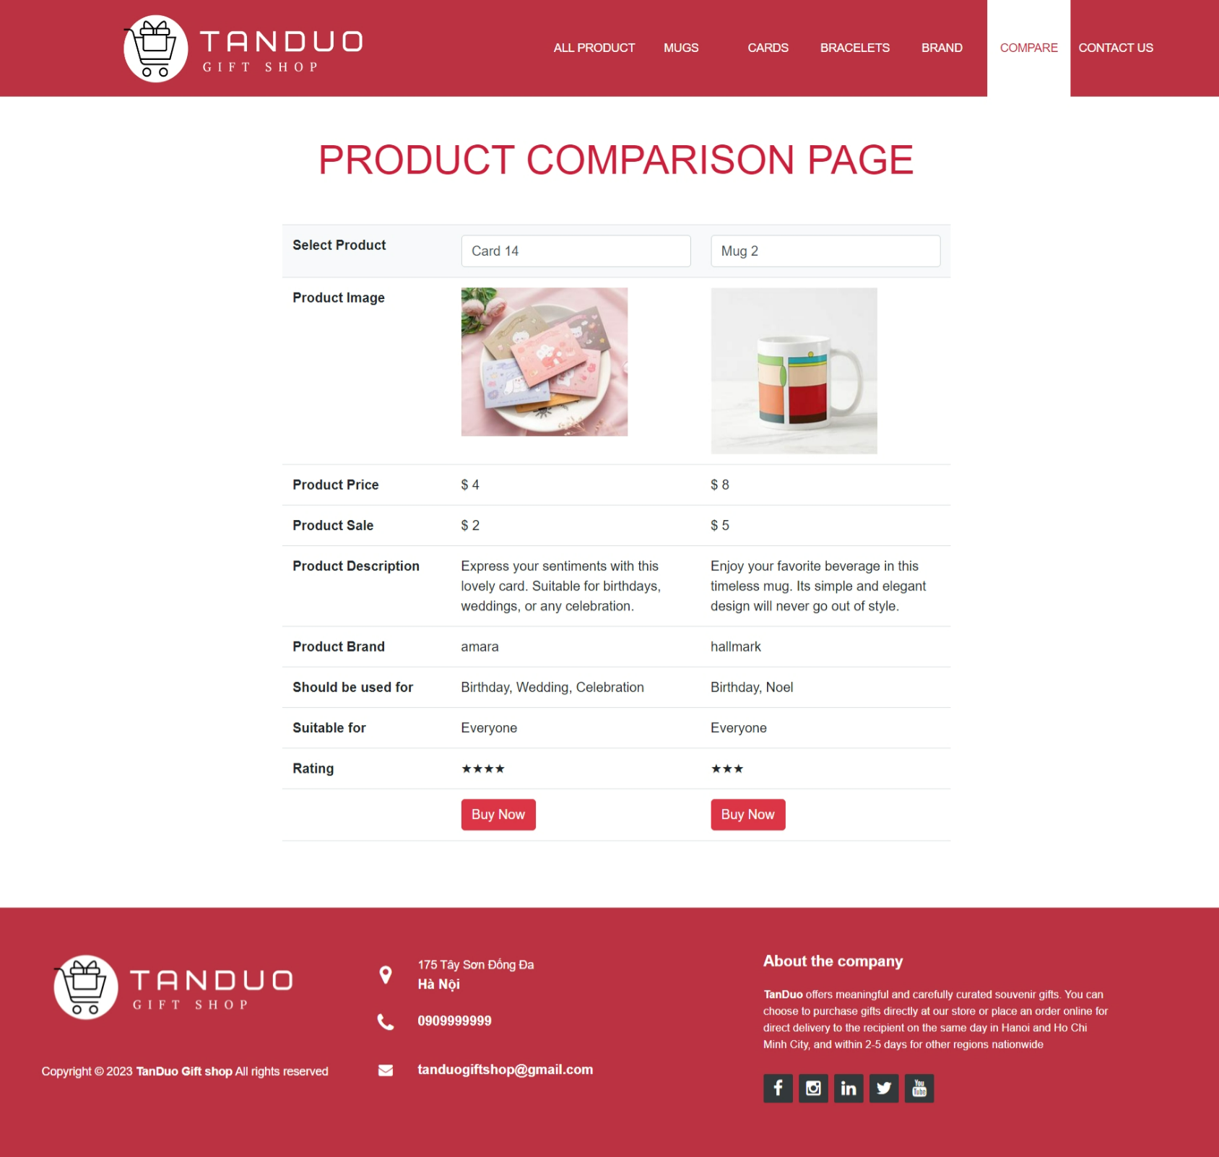

- Product detail

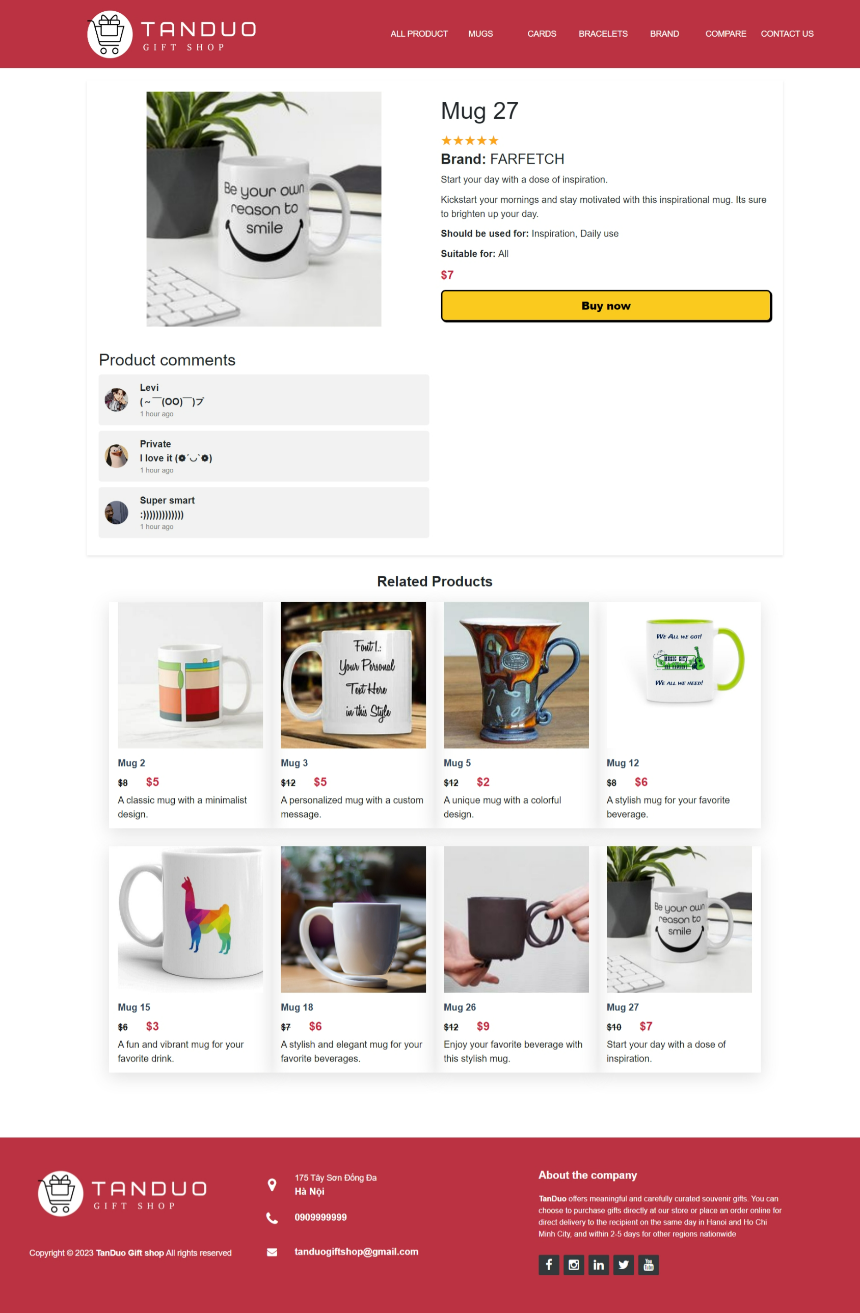

- Contact us page

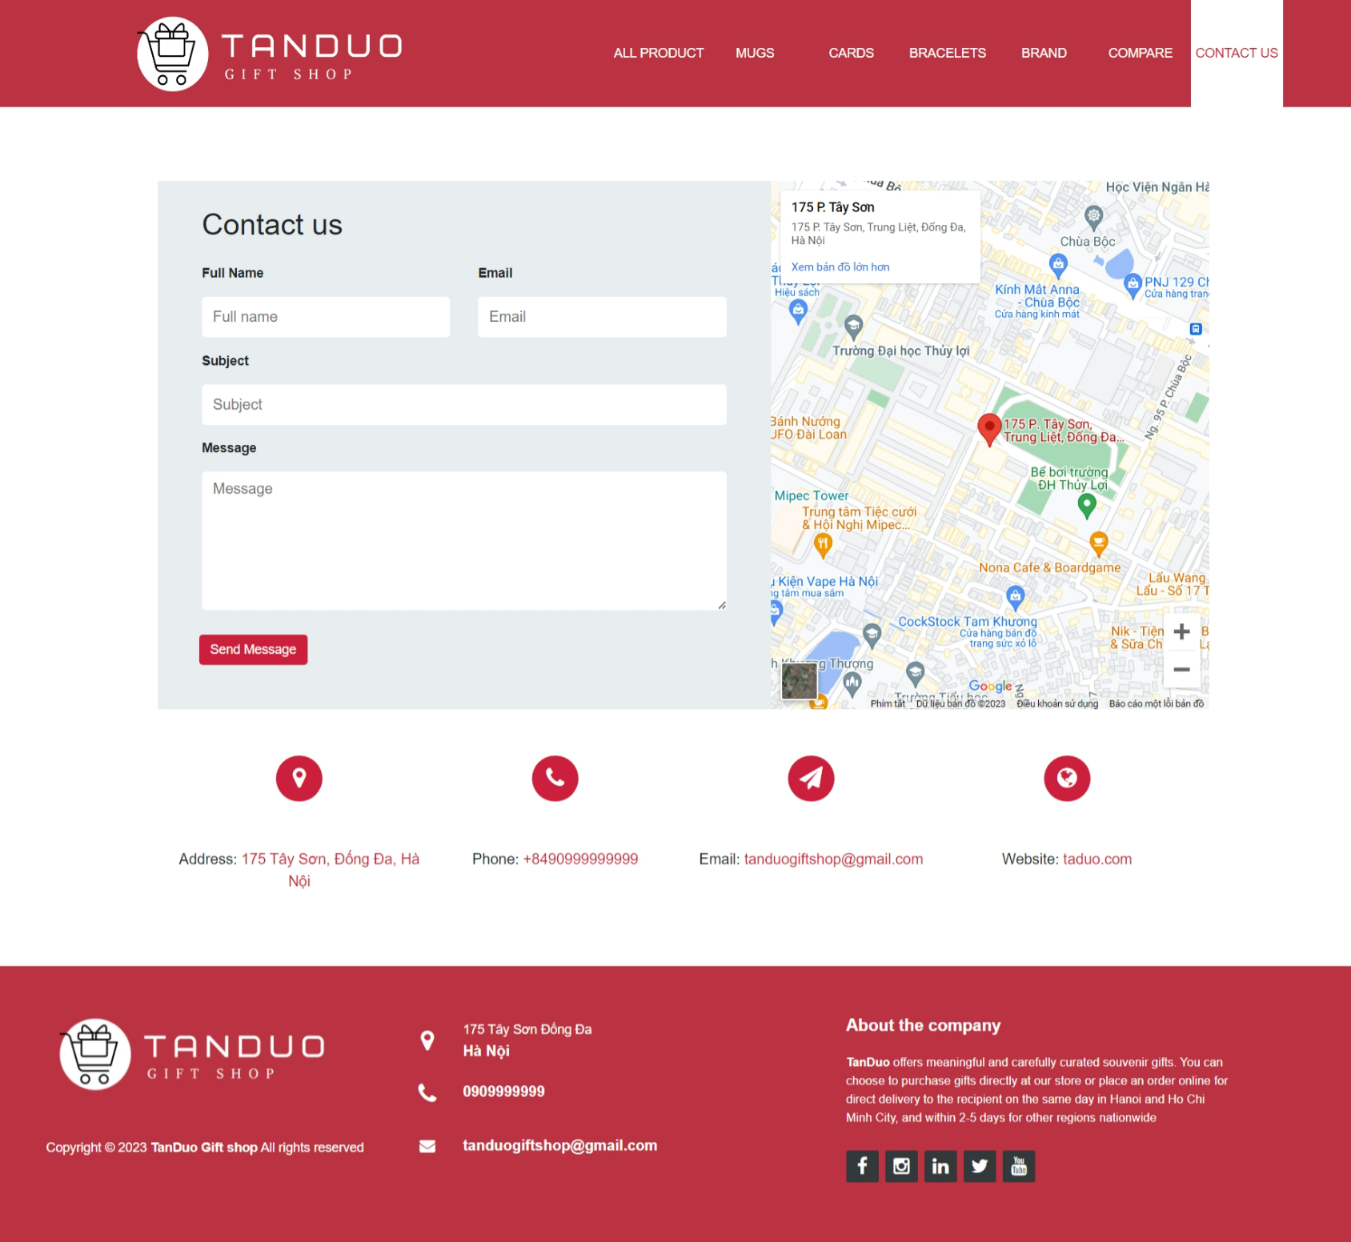

# User Guide

- On the homepage, users can see advertisements and recommended products. They can directly click on a product to view its details or choose to browse products by category, such as Mugs, Cards, Bracelets, or by brand.

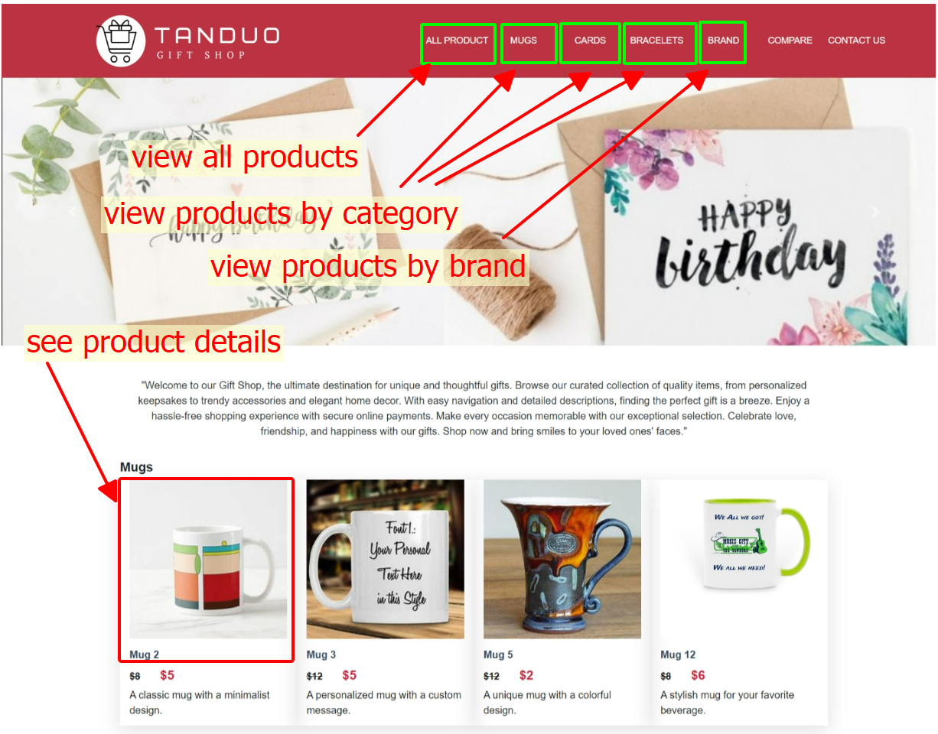

- On the product detail page, users can see the image, name, rating, short description, description, price, ideal occasions for gifting, occasions for using, and target audience of the product. Users can also refer to the comments section to gather insights from other users and make informed decisions in choosing the best product. If they want to explore similar products, they can check out the related products section.

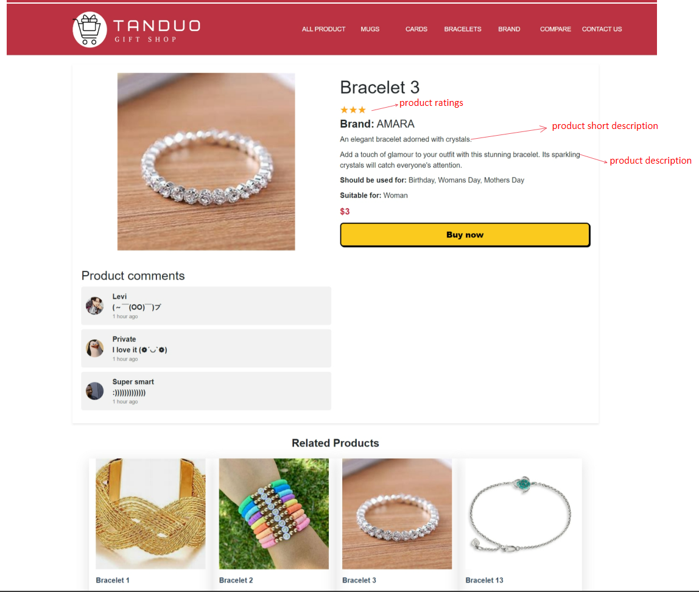

- On the "All Products" page, users can read an introduction about our store and browse through all products available at TANDUO Gift Shop. They can also search for products based on their desired criteria such as Category, Brand, Name, Min Price, and Max Price. The search results will be displayed below, showing the quantity and details of the found products that match the user's search.

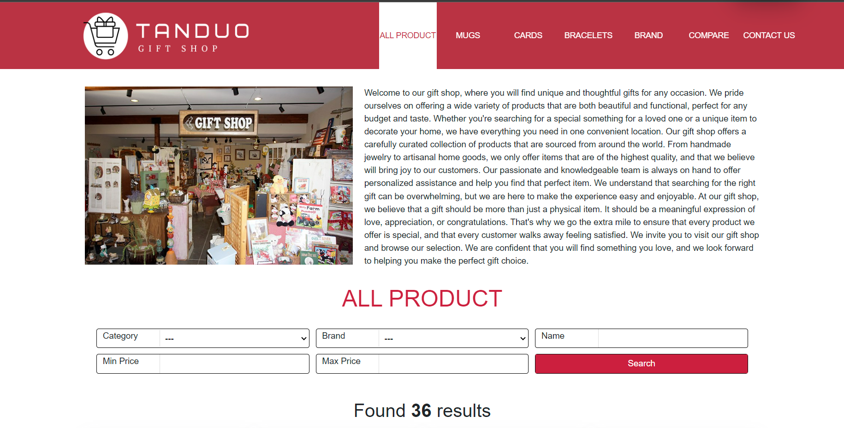

- On the "Product Comparison" page, users can click on the select product dropdown to choose 2 products they wish to compare. The website will then display the characteristics of both products and assist users in making the best choice.

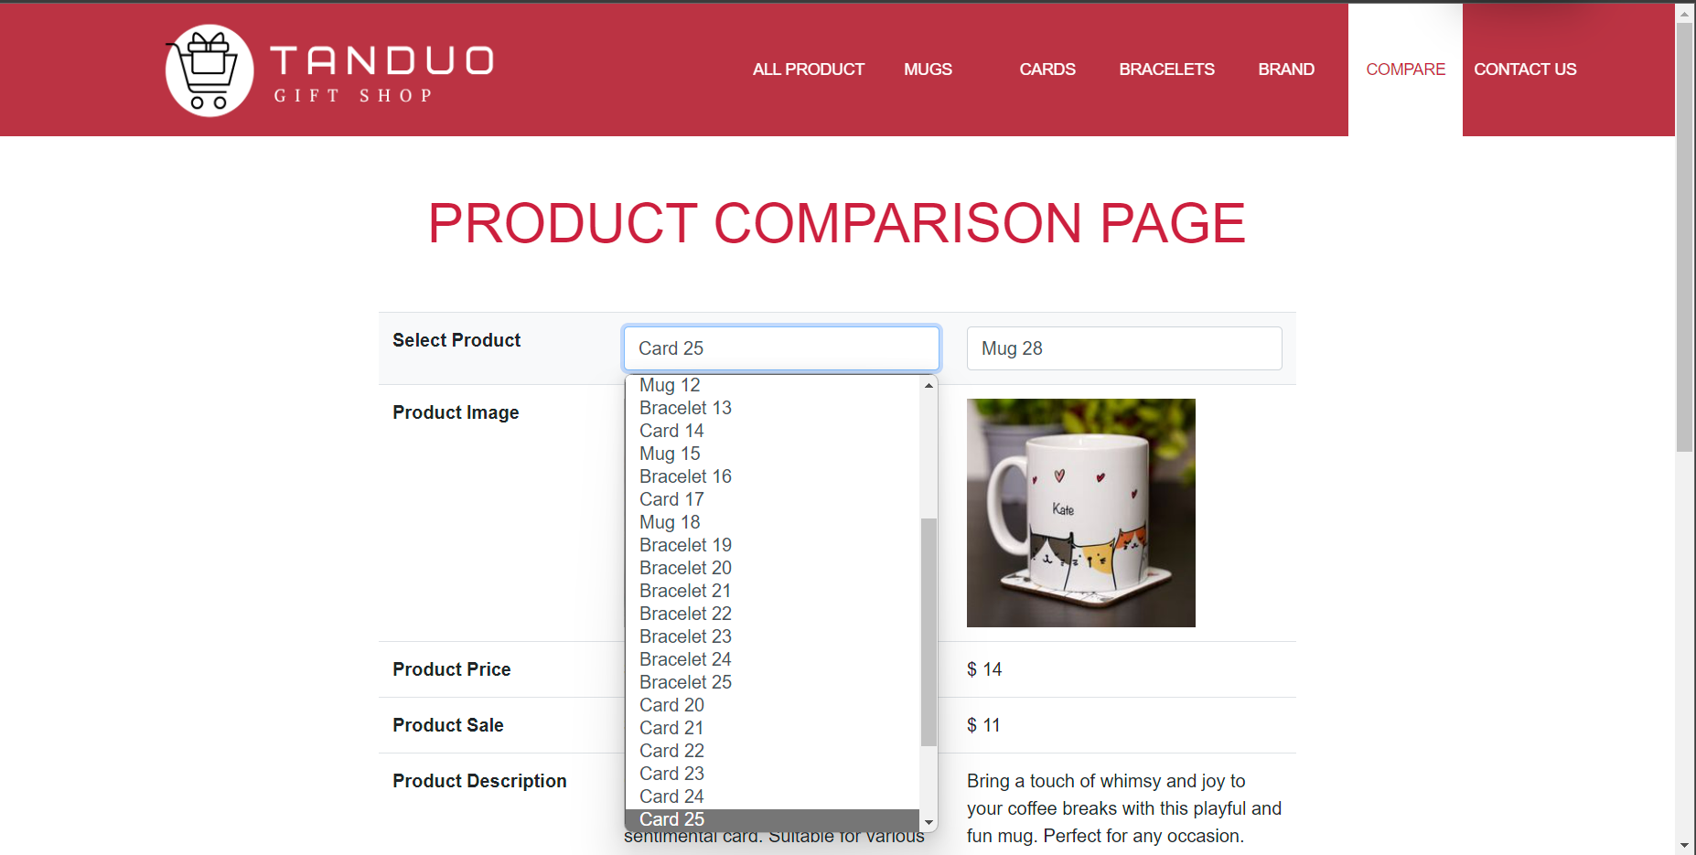

- On the "Contact Us" page, users can find the location of our store. Customers are welcome to visit our store for personalized advice and support. If visiting the store is not possible, customers can still contact us via phone, email, or by filling out the information directly on our "Contact Us" page. Please remember to provide complete information such as full name, email, subject, and message so that we can provide the best assistance.

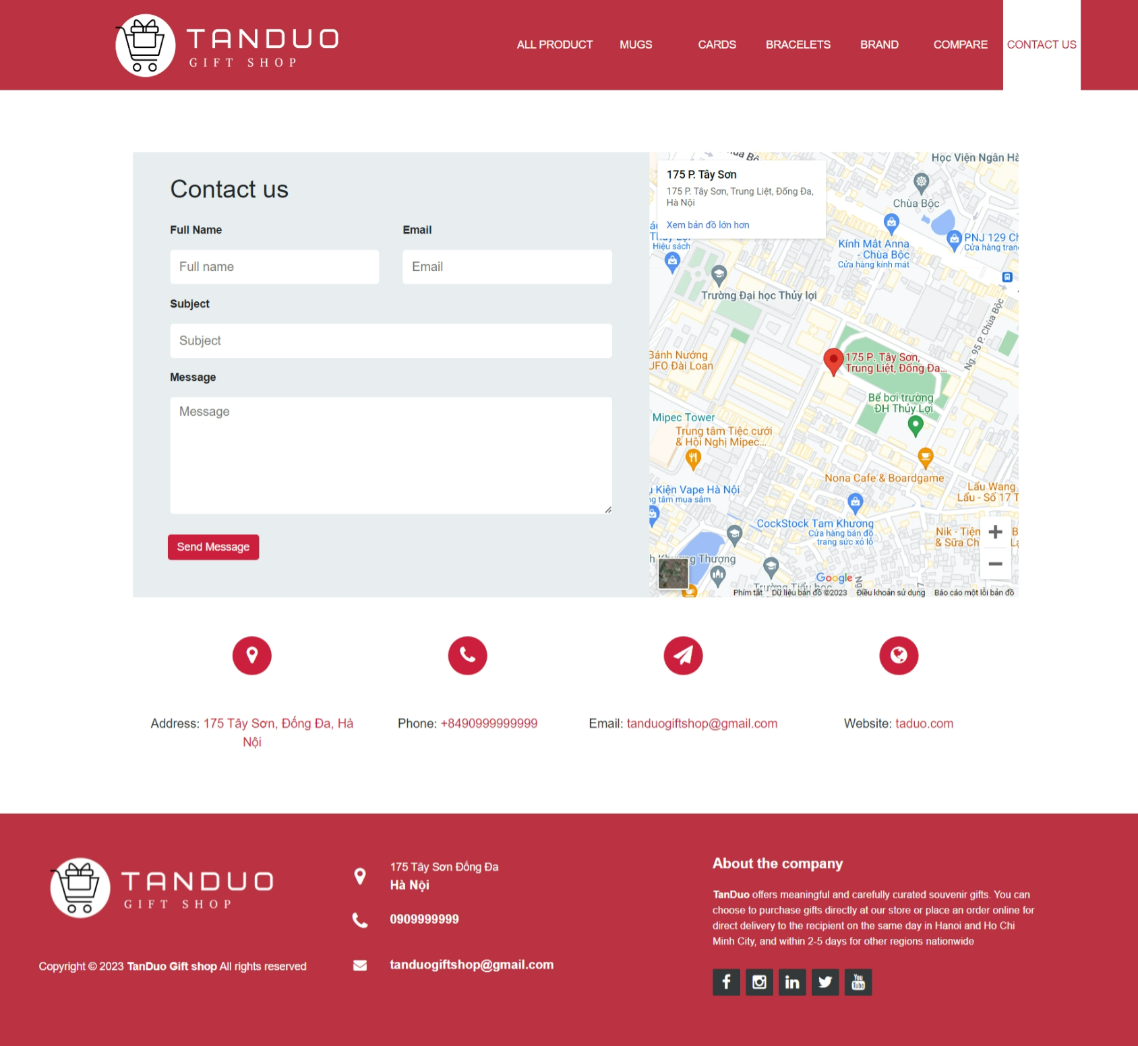The End